**Bahria University, Lahore Campus**

Department of Computer Sciences

Lab Journal 02

**(Fall 2023)**

|  |  |  |
| --- | --- | --- |
| Course: | **Database Management System Lab** |  |
| Course Code: | CSL 220 | Max Marks: 40 |
| Faculty’s Name: | Maryam Munawar | Lab Engineer: |

Name: AFFAN AHMAD __ Enroll No: _03-134221-003___

Objectives

Data Retrieval Language / Data Query Language (DRL/DQL):

The objective of this lab session is to **learn some data retrieval methods using** Select Statement.

By the end of this lab students will be able

* To implement **data retrieval methods using** Select Statement

## Lab Tasks:

**Consider The Following Schema**

**Table 1**

create database select_lab;

create table employee

(Employee_Number int Not Null,

Employee_Name varchar(15) Not Null,

job varchar(10) Not null,

Manager int ,

Salary numeric (7,2),

Datee DATE,

);

insert into employee values(1,'amna' , 'lecturer' , '25000', 0, '25 june 2000')

insert into employee values(2,'bisma' , 'student Advisor ' , '20000', 0, '25 june 2015')

insert into employee values(3,'iqra' , 'sweeper' , '5000', 0, '5 january 2007');

insert into employee values(4,'saba' , 'lecturer' , '25000', 0, '7 december 2009');

insert into employee values(5,'ali' , 'lecturer' , '25000', 0, '10 march 2017');

insert into employee values(6,'ahmad' , 'lecturer' , '25000', 0, '1 october 2010');

select * from employee

----------------------------------------------------------------------------------------

----------------------------------------------------------------------------------------

**Table 2**

Create Table DEPARTMENT

(Department_No int ,

Department_Name varchar(25),

Location varchar (20)

);

insert into department values(1, 'English', 'Lahore' );

insert into department values(2, 'Urdu', 'Lahore' );

insert into department values(3, 'Computer', 'Lahore' );

insert into department values(1, 'finance', 'Lahore' );

----------------------------------------------------------------------------------------

----------------------------------------------------------------------------------------

**Task 1 30 Minutes**

1. List all information of employee table

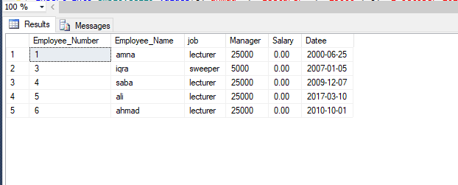

1. List all data from Department table

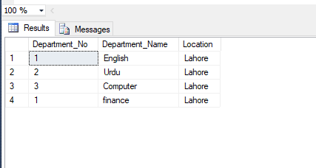

1. List information of both tables ‘Employee’ and ‘Department’.





1. List the employee_no, employee_name, job of employee from the employee table.

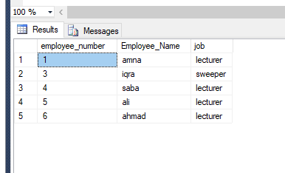

1. List the name, salary of the employees

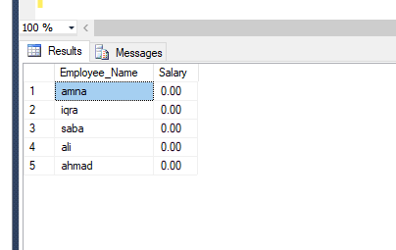

**Task 2 25 Minutes**

1. List name and annual salary of all the employees

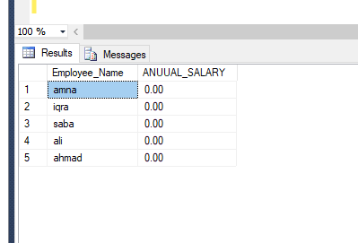

1. Write a query to display the Employe_name and yearly salary using alias “Monthly Salary",

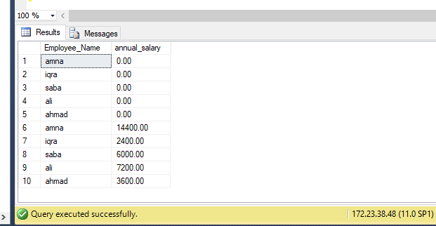

1. Write a query to get unique department_No from Department table

select distinct Department_No from department129

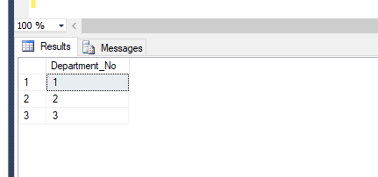

1. Write a query to get unique employee_Number from Employee table

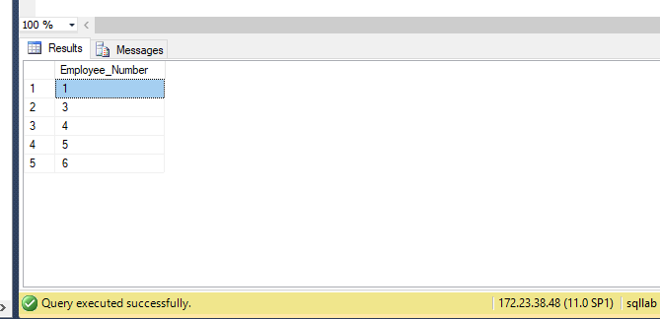

**Task 3 30 Minutes**

1. Write a query to get all employee details from the employee table order by name, descending

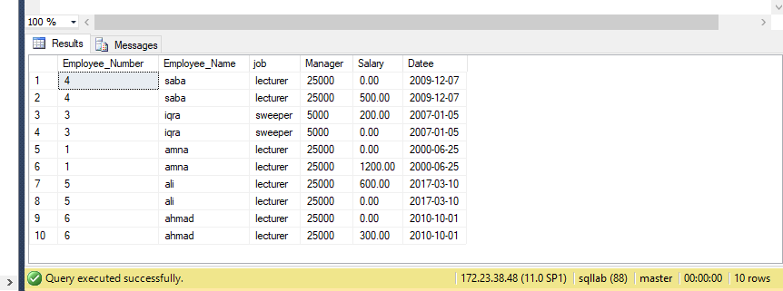

1. Write a query to get the employee_No, Employee_names, salary in ascending order of salary

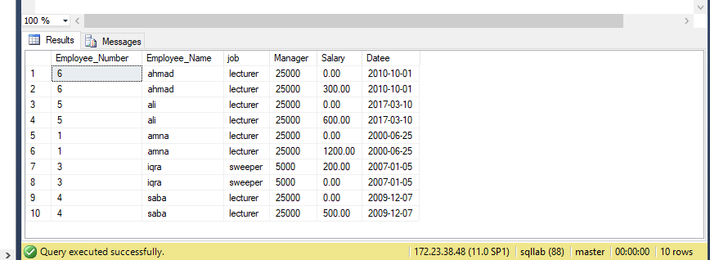

1. Write a query get all Employee_name from employees table in upper case

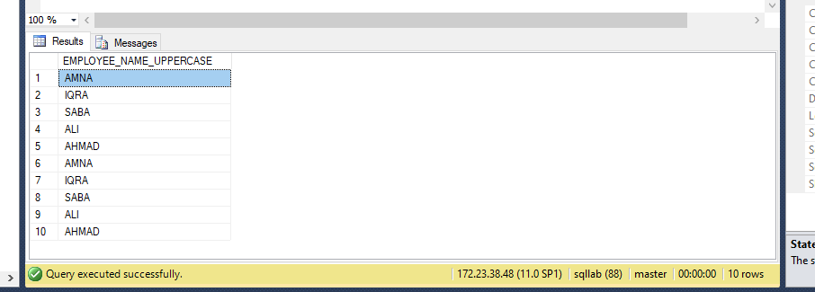

1. Write a query to get all jobs from employee table in lower case

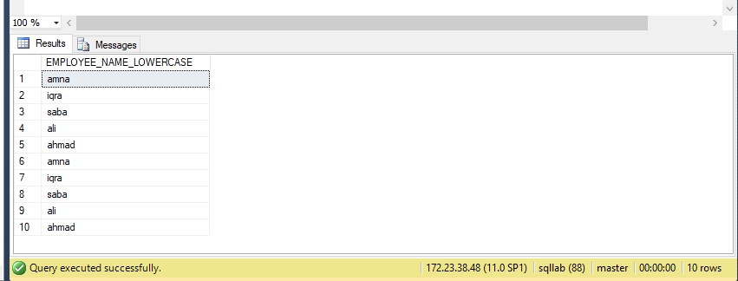

1. Write a query to get the Employee_names and Employee_Number (for example 12 hadia etc.) of all the employees from employees table

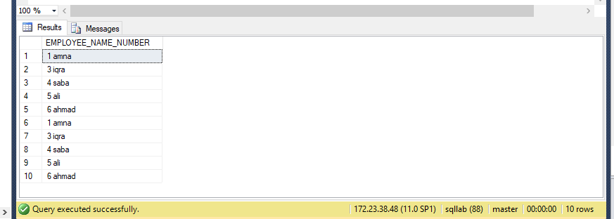

**Task 4 30 Minutes**

1. Write a query to get the first 2 characters of Employee_name from employee table

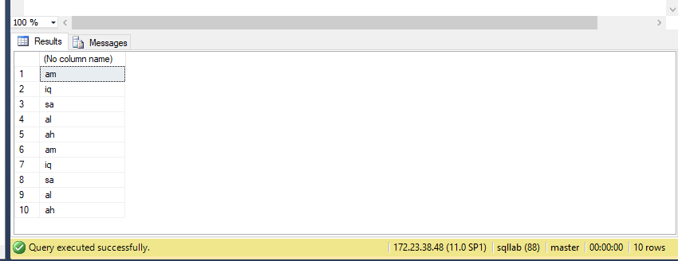

1. Write a query to get the first 3 characters of location from Department table

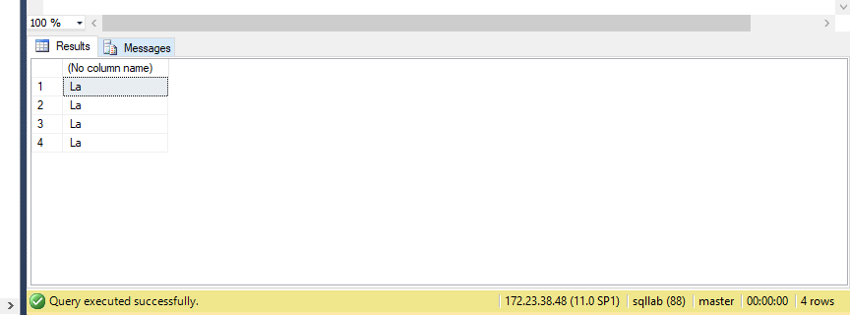

1. Write a query to calculate 171*214+625

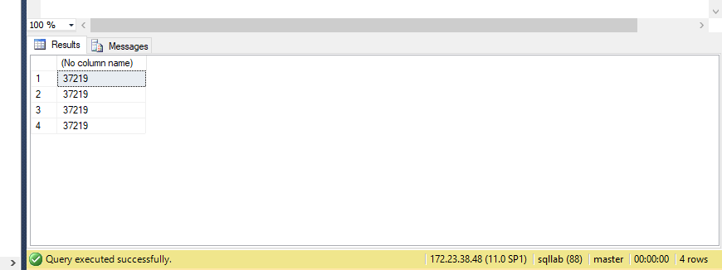

1. Write a query to print the result of (121*22+44) and name the result set as Result using as keyword

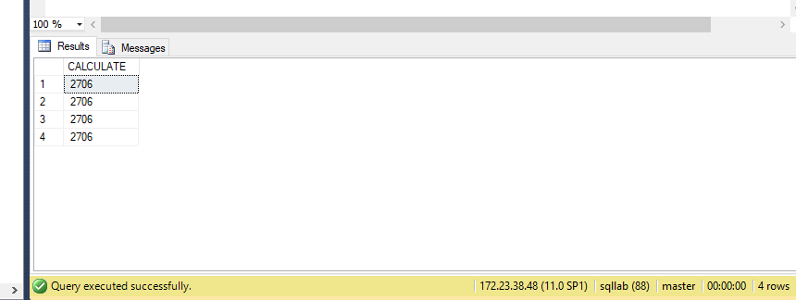

1. Display your name and enrollment and name the column as “ My_Details”

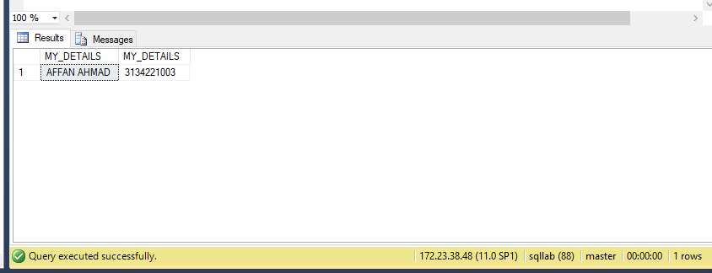

**Lab Grading Sheet :**

|  |  |  |  |
| --- | --- | --- | --- |
| **Task** | **Max Marks** | **Obtained Marks** | **Comments(*if any*)** |
| 1. | 10 |  |  |
| 2. | 10 |  |  |
| 3. | 10 |  |  |
| 4. | 10 |  |  |
| **Total** | **40** |  | **Signature** |

**Note : Attempt all tasks and get them checked by your Lab. Instructor**